

**Name: Sailingyacht A**

**Price: 1390$/hour**

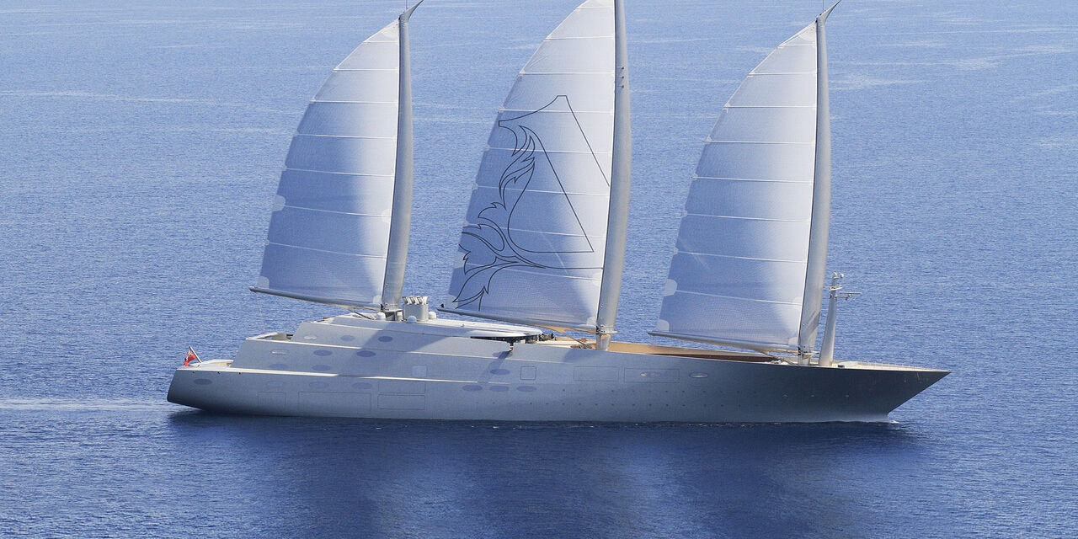

The award winning 142.81m/468'6" motor/sailer yacht 'Sailing Yacht A' was built by Nobiskrug in Germany at their Rendsburg shipyard. Her interior is styled by design house Philippe Starck and she was delivered to her owner in January 2017

Sailing Yacht A is built with a steel hull and steel / grp superstructure, with teak decks. Powered by twin diesel-electric MTU (20V 4000 M73L) 20-cylinder 4,895hp engines running at 2050rpm, she comfortably cruises at 16 knots, reaches a maximum speed of 21 knots with a range of up to 5,320 nautical miles at 16 knots. She was built to Lloyds Register ✠ 100A1 Passenger ship Sail Assisted, ✠ LMC UMC ✠ 100A1 Yacht Mono G6 classification society rules.

|  |  |
| --- | --- |
|  |  |
|  |  |
|  |  |
|  |  |

|  |
| --- |
| ***​*** |
|  |
|  |

***​DESCRIPTION***

|  |  |  |  |
| --- | --- | --- | --- |
|  | **Long 50m** |  | **Wide 10m** |
|  | **25 Room** |  | **48 Owner & guest** |
|  | **1 x 300 HP** |  | **12 - 34 Knots** |
|  | **Day Charter** |  | **30 L/h** |

ROAD CHARTER

»» Sightseeing on the Saigon River by yacht in 2 hours.  
1. Sunset and city night life.  
2. Enjoy the freedom & fresh air.  
  
»» Saigon – Can Gio Mangrove Forest 4 hours.  
1. Enjoy the mangrove forest and the life of local fisherman.  
2. Buy and cook local seafood from the forest fisherman. The special seafood of brackish water.  
3. Sunset on the river  
4. Night life of the city  
  
»» Saigon – Vung Tau City  
1. The trip will go through Can Gio Mangrove Forest.  
2. Swimming in the open sea (near the coastine)  
3. Sunset on the river  
4. Night life of the city